**STOCK DOCUMENTATION IN ERPNEXT**

**WAREHOUSE TREE**

1.Go to the Warehouse list, click on New.

2. Enter a name for the Warehouse.

3. Set/check the Parent Warehouse. If you tick on 'Is Group', you can create sub-Warehouses under this group Warehouse.

4. Save.

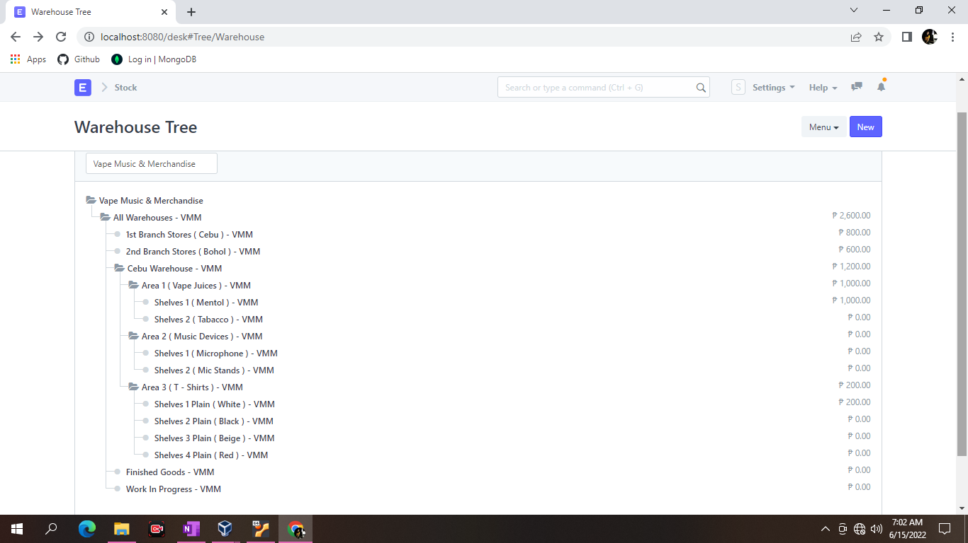

AFTER CREATING WAREHOUSE, YOU NEED TO PUT STOCKS IN BRANCHES AND ALSO ON HOW WE TRANSFER THE STOCKS IN WAREHOUSE WHICH IS THERE IS A LOCATION AND SHELVES EACH LOCATION.

**MATERIAL REQUEST**

1. Go to the Material Request list, click on New.
2. Enter the required by date.
3. Select from one of the purposes as listed above.
4. You can fetch Items from a BOM, Sales Order, or Product Bundle.

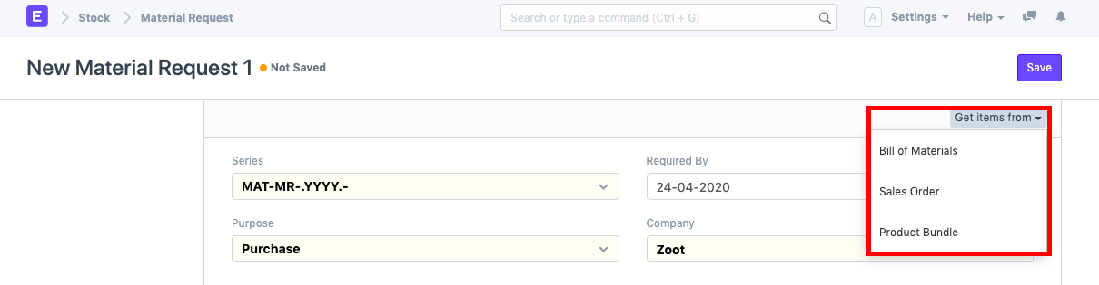

1. Select the Item and set the quantity.
2. Select the Warehouse for which Items are required.
3. You can change the Required By date for individual Items in this table.
4. Save and Submit.

**Purchase Receipts**

Purchase Receipts are made when you accept Items from your Supplier usually against a Purchase Order.

1. Go to the Purchase Receipt list, click on New.
2. The Supplier name and the Items can be fetched from the Purchase Order by clicking on 'Get Items from > Purchase Order'.
3. You can set the Accepted Warehouse for all items in this Purchase Receipt. This is fetched if set in Purchase Order.
4. In case any Items are defective, set the Rejected Warehouse where those Items will be stored.
5. Select the Item and enter the quantity in the Items table.
6. The rate will be fetched and the amount will be calculated automatically.
7. You can expand the item row to change the Accepted Warehouse for an Item.
8. Save and submit.

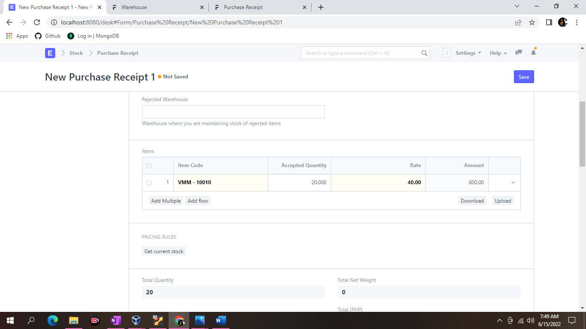

**STOCK ENTRY**

Stock Entries for Manufacturing purposes are usually created from a Work Order. To create a Stock Entry manually for other purposes, follow these steps:

1. Go to the Stock Entry list, click on New.

2. Select the Stock Entry Purpose from the ones listed above.

3. If you set the Default Source or Target Warehouses, they'll be automatically filled for the rows in the Items table.

4. Source/Target Warehouses will be available as per the Stock Entry Purpose you selected.

5. Select Items and enter a quantity.

6. The basic rate will be fetched and the amount will be calculated automatically.

7. Save and Submit.

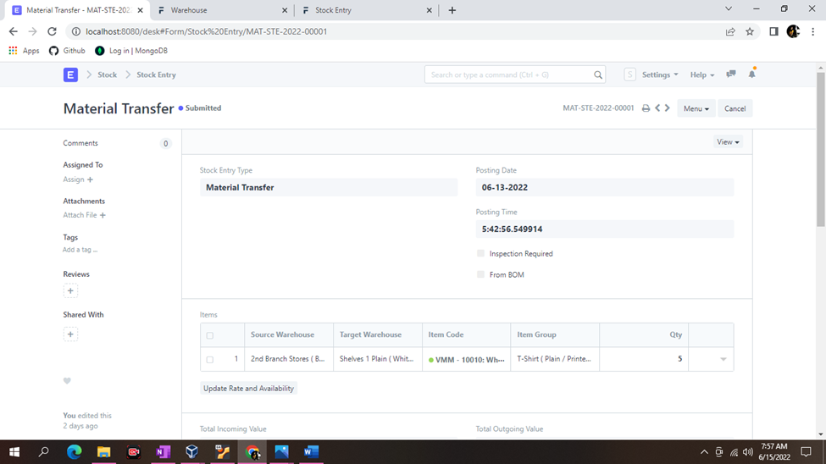

Usually, "Source Warehouse" and "Target Warehouse" both are set for recording a movement.

**DELIVERY NOTE**

The entry of the Delivery Note is very similar to a Purchase Receipt. It is usually created from a “Submitted” Sales Order (that is not shipped) by clicking on Create > Delivery.

1. Go to the Delivery Note list, click on New.
2. The Customer and Item details can be fetched by clicking on 'Get Items from > Sales Order'.
3. The UOM and Rates will be fetched automatically.
4. Save and Submit.

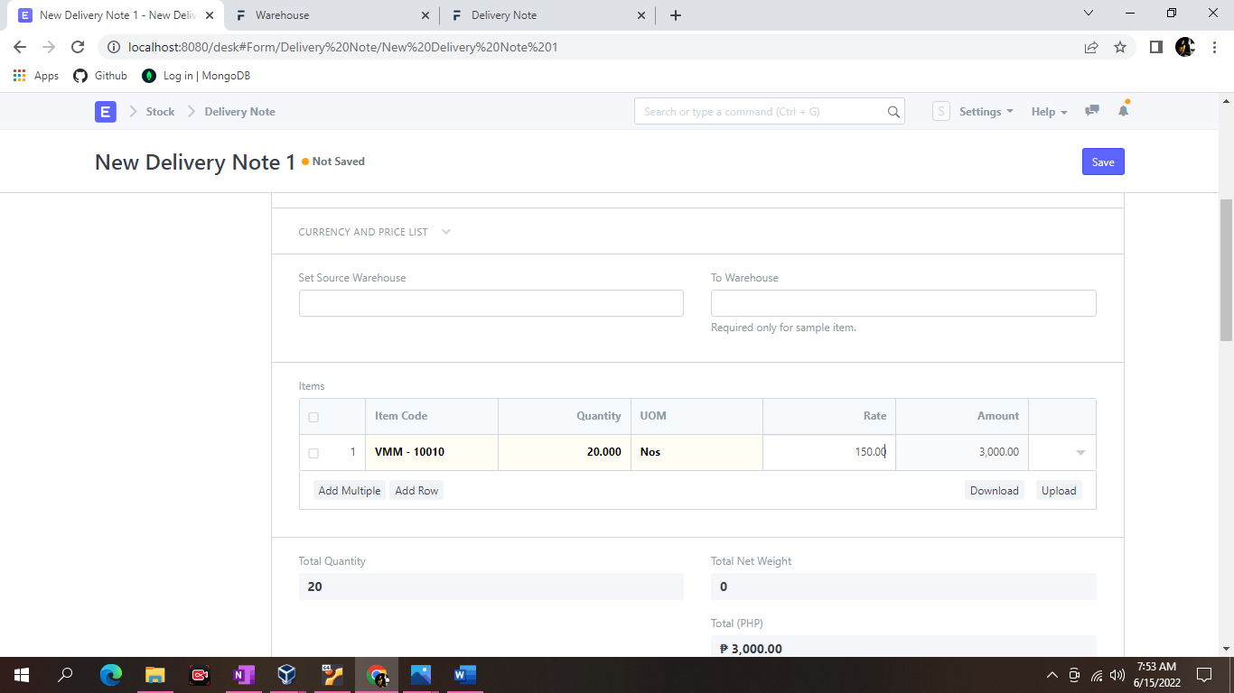

To fetch Items from a Sales Order, click on Get Items from > Sales Order. This will open a popup from where you can search for Sales Orders and select one.

You will notice that all the information about unshipped Items and other details are carried over from your Sales Order if you create the Delivery Note from there.

You can also edit the posting date and time the current date and time are set when you create the Delivery Note.